How to create a YAWL model for Simulator

Created on 2013/10/02

Fortune Truong ([fortune.truong@gmail.com](mailto:fortune.truong@gmail.com))

**Table of Contents**

Create Task Decompositions

Create Goal Default Value

Manually

By SQL Query

Setup Resources

Troubleshoot

# 

# 

# 

# Create Task Decompositions

Step 0: Right click on the Task, select “Select Task Decomposition...” > Create.

Step 1: Right click on the Task, select “Task Decomposition Detail...”

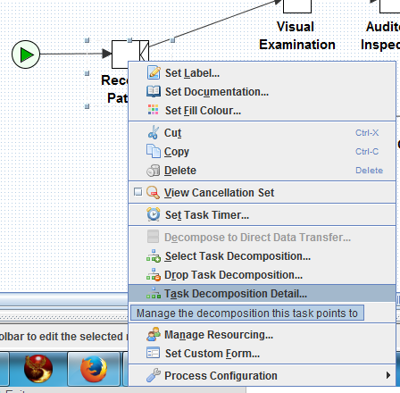

Step 2: Click “Create...” button

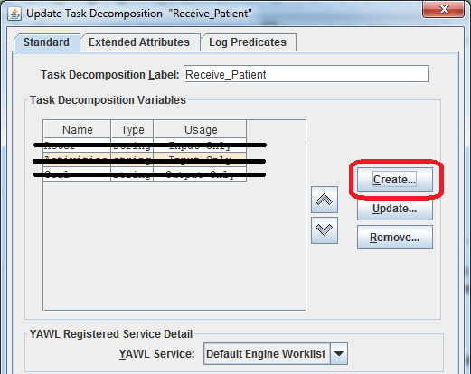

Step 3: Create a variable named “Tasks”, string, output only, which a string which described the task.

Important: NO SPACE in task default value. Underscore should be used if require a space.

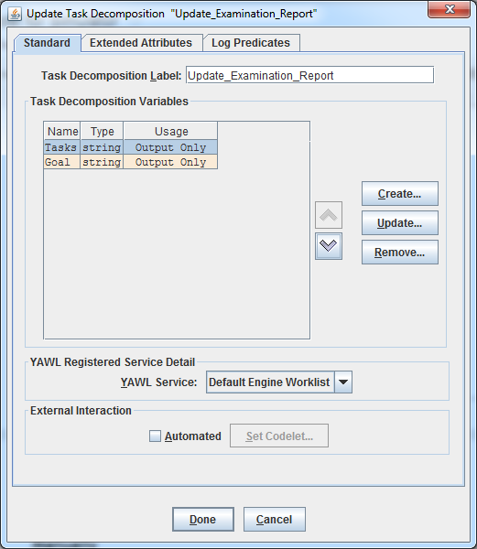

Step 4: Create a variable name “Goal”, type “string”, usage: “Output Only”.

**Hint:** “Goal” MUST go after “Tasks”, otherwise the simulator will not be able to get the next job.

Type in the Default Value textarea with the world state statement which fulfill the task. For more detail, see in the next section on how to create a Goal Default Value.

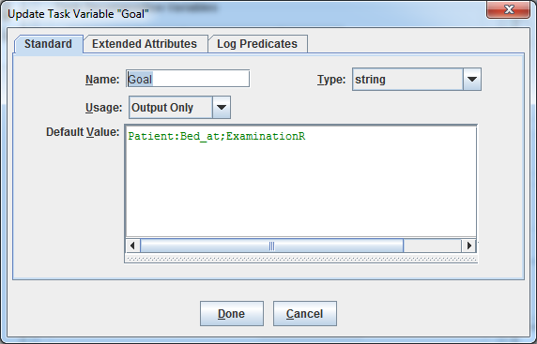

# Create Goal Default Value

## Manually

The format of the Goal Default value is:

|  |
| --- |
| [asset_name]:[predicate_label];[value] |

For instance:

Task “Receive Patient” need “Patient” is on a “Bed_at” the “Examination_Room”.

The Goal Default value is:

|  |
| --- |
| Patient:Bed_at;Examination_Room |



**Hint**: In some cases, the system will not be able to launch long Default Value, so sometime the knowledge base need to shorten the string. For the above example, instead of saying “Examination_Room”, “ExaminationR” used.

## 

## By SQL Query

Select view “possible_goals” to see the goal list

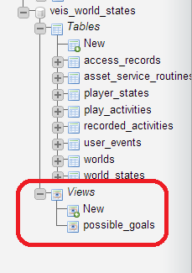

OR run this script in PhpMyAdmin to get the Goal list

Then copy the expected Goal to YAWL model.

|  |
| --- |
| SELECT distinct concat(a.asset_name, ":", a.predicate_label,";", d.value) as Goals  FROM  veis_world_states.world_states a,  veis_knowledge_base.method_post_conditions b,  veis_knowledge_base.variables c,  veis_knowledge_base.domain_values d  WHERE  a.predicate_label = b.predicate  AND  b.state = 1  AND  c.identifier = b.variable  AND  d.name = c.domain_name  AND  a.asset_name != "__FREE"  LIMIT 0,100 |

The result may look like follow:

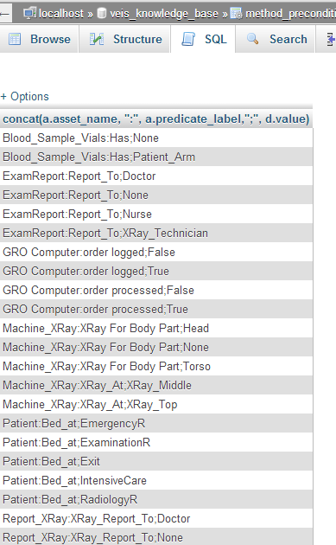

# Setup Resources

Right click on each task, then select Manage Resourcing…

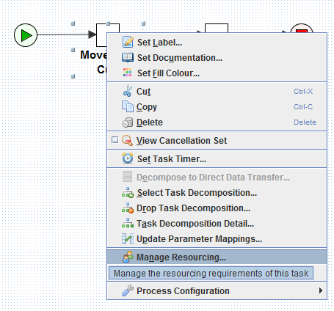

Chance option box of Offer from User to System, click Next

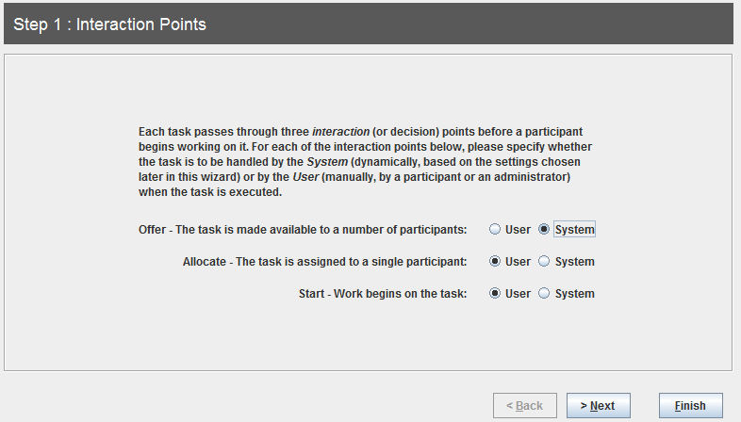

Pick the Role in the role list who expectedly does the task

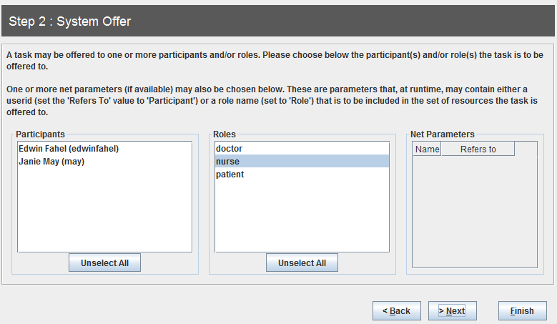

Leave blank for the rest by click Finish.

# 

# 

# Troubleshoot

If when the case launched successfully, but it run through the entire models automatically and unexpectedly, then should check if the “Tasks” contains any SPACE, and remove those spaces or replace by underscore.